1. **INTRODUCTION**

Bonafide Certificate is document given by college that certifies that the student belongs to the that college/school. To issue this certificate student has to go to the college office write an application take the sign of the HOD or Principal, pay the fees in bank, show the receipt in the office and then he or she receives the Bonafide certificate.This is very lengthy process and consumes valuable time of the student as well as the college staff. This time can be saved and put to good and productive activities. To achieve this goal we used our knowledge of computer science and programming to develop a webapp that will help students pay the fees online and generate their Bonafide Certificate through their computer or mobile phones. We have made this webapp using programming languages such as python, html, sql and the Django framework. You just have to access the url of the webapp in your browser and enter the required fields in the form and after pressing the submit button you will be redirected to the payment gateway where you can pay the fees by using online payment methods such as UPI. After the payment is successful you will get your certificate and a confirmation mail will be sent to your registered email.

Bonafide Certificate is document given by college that certifies that the student belongs to the that college/school. To issue this certificate student has to go to the college office write an application take the sign of the HOD or Principal, pay the fees in bank, show the receipt in the office and then he or she receives the Bonafide certificate. This is very lengthy process and consumes valuable time of the student as well as the college staff. This time can be saved and put to good and productive activities. To achieve this goal, we used our knowledge of computer science and programming to develop a webapp that will help students pay the fees online and generate their Bonafide Certificate through their computer or mobile phones. We have made this webapp using programming languages such as python,html,sql and the Django framework. You just have to access the url of the webapp in your browser and enter the required fields in the form and after pressing the submit button you will be redirected to the payment gateway where you can pay the fees by using online payment methods such as UPI. After the payment is successful you will get your certificate and a confirmation mail will be sent to your registered email.

**1.1 LITERATURE SURVEY**

We have selected this topic on the point of view of students,who are facing problems towards colleges due to COVID-19 lockdown the main reason for selecting this project was to give students an easy path to get their bonofide certificate online.Due to COVID-19 it is difficut for students to get their bonofide certificate physically from college and this is where our project can come usefull for students.

Due to online system our project will help college as well as students to fill information whenever and where ever they want.Online bonofide certificate generator should be provided to all the institute's, it will help students who has taken admisssion for the first time in colleges during lockdown.

**1.2 PROBLEM DEFINITION**

A bonafide certificate is something that is used as an identification/proof that we belong to a particular college/School. Normally the process to get the bonafide certificate is long and time consuming. To get the bonafide we need to get a form to fill the fee for the bonafide certificate then pay the fee at the bank at the same time apply for the bonafide and then we get the certificate that take time. Overall, it’s a lengthy process. Since this is a pandemic situation not all students can come to college and for their office work. Some of those work would be applying for leave certificate (LC). LC is something that takes time and verification higher authorities (HOD & Principle). It is just process of verification and the main problem is this pandemic and no one knows how long this will long. It is always better to be one step a head so here we stand fighting, developing our civilization by making things better, more efficient and powerful. We face this kind a small issues in our life that waste energy and time, 13 by automating this small, small things we proceed our next goal in computer science and technology. The main thing is time is changing, recording everything in a book or even manually updating the data in the software is sometimes slow and even has possibility or error inputs. Automating these small process benefits us in our life style.

**1.3 PROPOSED METHODOLOGY OF SOLVING IDENTIFIED PROBLEM**

To solve the above-described problem, we need a solution that is safer because the main purpose is, we need to be ready in this pandemic and we always need to be a step ahead. So, to be safe we need to prevent physical connect as much as possible.

To do this we need virtual office and virtual payment methods and virtual verification.To overcome this obstacle that are faced by many students everywhere, online was the best option to make the process safer and faster.

Well, why online? The main purpose of modification of these office paper work is safety and speed. Time is changing and we need upgrading our systems. It is also very easy to access wherever you are.

**1.4 RESOURCES AND COSUMABLES REQUIRED**

* HTML – Hypertext Markup Language is the standard markup language for documents designed to be displayed in a web browser. It can be assisted by technologies such as Cascading Style Sheets and scripting languages such as JavaScript.
* CSS – Cascading Style Sheets is a style sheet language used for describing the presentation of a document written in a markup language such as HTML. CSS is a cornerstone technology of the World Wide Web, alongside HTML and JavaScript
* Python –Python is an interpreted, high-level and general-purpose programming language. Python's design philosophy emphasizes code readability with its notable use of significant whitespace.
* Djongo –Django is a Python-based free and open-source web framework that follows the model-template-views architectural pattern. It is maintained by the Django Software Foundation, an American independent organization established as a 501 non-profit.
* Sqlite -SQLite is a relational database management system contained in a C library. In contrast to many other database management systems, SQLite is not a client–server database engine. Rather, it is embedded into the end program.
* Git –Git is a software for tracking changes in any set of files, usually used for coordinating work among programmers collaboritively developing source code during software development. Its goals include speed, data integrity, and support for distributed, non-linear workflows.
* Github – GitHub, Inc. is a provider of Internet hosting for software development and version control using Git. It offers the distributed version control and source code management functionality of Git, plus its own features.
* Visual Studio Code -Visual Studio Code is a free source-code editor made by Microsoft for Windows, Linux and macOS. Features include support for debugging, syntax highlighting, intelligent code completion, snippets, code refactoring, and embedded Git.

**1.5 Purpose of the Project**

1)The main aim of this project is to provide user-friendly environment to the student to get the Bonafide certification in online.

2)In the proposed system student can get the service by filling the form online. There is no wastage of paperwork. It reduces the burden of people who are involving in that process. Notifications are sent to their mobile (emails) after the approval of the request.

3)Bonafide certificate issuing duration will be different for different institution. It is issued on printed letter head of the institution and duly signed/ stamped

4)Bonafide Certificate is a document which is issued as a proof that an individual belongs to the particular education institute or a particular organization.

**1.6 Existing System**

There are websites like google form and other form filling websites which can be integrated with websites and tools like <https://www.certifyem.com/> to generate certificates.

**DISADVANTAGES**

Most of them have watermark on free versions and we have to pay for premium services.

**1.7 Proposed System**

We wanted to create a custom certificate generation system That will not have any watermark and we wanted to add payment gateway to pay the fees for the certificate generation and to make the process more secure.

**ADVANTAGES**

1)System protects the original data from unauthorized user

2)Easy to implement

3)Payment gateway with multiple payment options.

**1.8 Hardware/Software Required**

Processor -- Intel i3 or above

Ram -- 4 GB or more

Web Browser – Chrome / Safari

**Software Used**

1. Operating System – Windows 10

2. Application Server – Django Default

3. Front End – HTML, CSS

4. Scripts - Python

5. Server-side Script – Python (Django)

6. Database – SQ Lite

7. IDE – Visual Studio Code / Pycharm

**After Implementation**

1)A simple and easy to use service will be available for the students.

2)Students will no longer have to wait in line for hours and wait for principles sign. 3)Students can pay the fees through their UPI or any other online payment methods.

**1.9 Future Scope**

This system can be implemented to provide other kind of certificates too with or without payment gateway, or to provide students result or other documents.

**2.SYSTEM ANALYSIS**

**Introduction**

This section gives background information about specific requirements of Online bonafide certificate generator to be developed in brief. Although we will not describe every requirement in detail, this section will describe the factors that affect the final product.

**2.1 Analysis Model**

This model is basically being followed is the SOFTWARE DEVELOPMENT LIFE CYCLE MODEL, which states that the phases are organized in linear order. First of all feasibility study is done. Once that part is over the requirement analysis and project planning begins. If the system exists one then modification and addition of new module is needed, analysis of present system can be used as basic model. The design starts after the requirement analysis is complete and the coding begins after the design is complete. Once the programming is completed, the testing is done. In this model the sequence of activities performed in a software development.

**2.2 Study of the System**

**2.2.1 GUI’s**

In the flexibility of the user the interface has been developed a graphics concept in mind, associated through a browser interface. The GUI’s at the top level have been categorized as:

* Administrator user interface The administrative user interface concentrate on the consistent information that is practically, part of the organizational activities and which needs proper authentication for the data collection. The interface helps the administrator with all the transactional states like data insertion, Data deletion and data updating along with the extensive data search capabilities.
* The operational or generic user interface The operational or generic user interface helps the users upon the system in communicate through the existing data and required services. The operational user interface also helps the ordinary users in managing their own information in a customized manner as per the assisted flexibilities.

**3.FEASIBILTY REPORT**

**Introduction**

Preliminary investing examine project feasibility, the likelihood the system will be useful to the peoples. The main objective of the feasibility study is to study is to test Technical, Operational and Economical feasibility for adding new modules and debugging old running system. All system is feasible if they are aspect in the feasibility study portion of the preliminary investigation

**3.1 Technical Feasibility**

The technical issue usually raised during the feasibility stage of the investigation includes the following:

• Does the necessary technology exist to do what it suggests?

• Does the proposed equipment have the technical capacity to hold the data required to use the new system?

• Will the proposed system provides adequate response to enquiries, regardless of the number or location of users?

• Can the system be upgraded if developed? Are not many and are already available in-house at NIC or are available as free as open source. The work for the project is done with the current equipment and existing software technology. Necessary bandwidth exists for providing a fast feedback to the users irrespective of the number of users using the system.

**3.2 Operational Feasibility**

Proposed projects are benefits only they can be turned out into information system. That will meet the people’s requirements. Operational feasibility aspects of the project are to be taken as an important part of the project implementation. Some of this important issue raised is to test the operational feasibility of a project includes the following:

• Will the system be used and work properly if it being developed and implemented?

• Will there be any resistance from the user that will undermine the possible application benefits?

**4.TECHNOLOGY**

**4.1 Python**

Python is a general-purpose interpreted, interactive, object-oriented, and high-level programming language. It was created by Guido van Rossum during 1985- 1990. Like Perl, Python source code is also available under the GNU General Public License (GPL). Python is a MUST for students and working professionals to become a great Software Engineer specially when they are working in Web Development Domain. Some of the key advantages of learning Python:

1.Python is Interpreted − Python is processed at runtime by the interpreter. You do not need to compile your program before executing it. This is similar to PERL and PHP.

2.Python is Interactive − You can actually sit at a Python prompt and interact with the interpreter directly to write your programs.

3.Python is Object-Oriented − Python supports ObjectOriented style or technique of programming that encapsulates code within objects.

4.Python is a Beginner's Language − Python is a great language for the beginner-level programmers and supports the development of a wide range of applications from simple text processing to WWW browsers to games

**4.2 Django**

Django is a Web Application Framework which is used to develop web applications. Django is a high-level Python web framework that enables rapid development of secure and maintainable websites. Built by experienced developers, Django takes care of much of the hassle of web development, so you can focus on writing your app without needing to reinvent the wheel. It is free and open source, has a thriving and active community, great documentation, and many options for free and paid-for support.

Django can be (and has been) used to build almost any type of website — from content management systems and wikis, through to social networks and news sites. It can work with any client-side framework, and can deliver content in almost any format (including HTML, RSS feeds, JSON, XML, etc).

The site you are currently reading is built with Django! Internally, while it provides choices for almost any functionality you might want (e.g. several popular databases, templating engines, etc.), it can also be extended to use other components if needed.

**History:**

Django was initially developed between 2003 and 2005 by a web team who were responsible for creating and maintaining newspaper websites. After creating a number of sites, the team began to factor out and reuse lots of common code and design patterns. This common code evolved into a generic web development framework, which was open-sourced as the "Django" project in July 2005

**4.3 HTML**

HTML (Hypertext Markup Language) is the code that is used to structure a web page and its content. For example, content could be structured within a set of paragraphs, a list of bulleted points, or using images and data tables.

The HyperText Markup Language, or HTML is the standard markup language for documents designed to be displayed in a web browser. It can be assisted by technologies such as Cascading Style Sheets and scripting languages such as JavaScript.

Hyper Text Markup Language (HTML) is a markup language for creating a webpage. In easier words, HTML is a kind of programming language that can make a new webpage. Webpages are usually viewed in a web browser. 40 They can include writing, links, pictures, and even sound and video.

HTML is used to mark and describe each of these kinds of content so the web browser can display them correctly. HTML also adds meta information to a webpage. Meta information is usually not shown by web browsers and is data about the web page, e.g., the name of the person who created the page.

Cascading Style Sheets (CSS) is used to style HTML elements while JavaScript is used for website behavior and also changing the HTML and CSS. HTML is made by the World Wide Web Consortium (W3C). There are several versions of HTML. As of September 2018, the current standard of HTML is dubbed HTML 5 and is specifically at version 5.2

**4.4 Sqlite**

SQLite is a relational database management system contained in a C library. In contrast to many other database management systems, SQLite is not a client– server database engine. Rather, it is embedded into the end program. SQLite generally follows PostgreSQL syntax SQLite is a software library that implements a selfcontained, serverless, zero-configuration, transactional SQL database engine.

SQLite is one of the fastestgrowing database engines around, but that's growth in terms of popularity, not anything to do with its size. The source code for SQLite is in the public domain. SQLite is an in-process library that implements a selfcontained, serverless, zero-configuration, transactional SQL database engine.

The code for SQLite is in the public domain and is thus free for use for any purpose, commercial or private. SQLite is the most widely deployed database in the world with more applications than we can count, including several high-profile projects. SQLite is an embedded SQL database engine. Unlike most other SQL databases, SQLite does not have a separate server process. SQLite reads and writes directly to ordinary disk files.

A complete SQL database with multiple tables, indices, triggers, and views, is contained in a single disk file. The database file format is crossplatform - you can freely copy a database between 32-bit and 64-bit systems or between big-endian and littleendian architectures. These features make SQLite a popular choice as an Application File Format.

SQLite database files are a recommended storage format by the US Library of Congress. Think of SQLite not as a replacement for Oracle but as a replacement for fopen() SQLite is a compact library.

With all features enabled, the library size can be less than 600KiB, depending on the target platform and compiler optimization settings. (64-bit code is larger. And some compiler optimizations such as aggressive function inlining and loop unrolling can cause the object code to be much larger.)

There is a tradeoff between memory usage and speed. SQLite generally runs faster the more memory you give it. Nevertheless, performance is usually quite good even in low-memory environments. Depending on how it is used, SQLite can be faster than direct filesystem I/O.

**5.SYSTEM DESIGN**

**5.1 ALGORITHM**

1. Start

2. Fill the information

3.If the student data is valid then go to step 5 Else go to step 4

4.Throw an error saying student not present

5.Redirect the user to the payment gateway

6.If the payment is successful then generate and redirect the student to the bonafide certificate of that student

7.End

**5.2 FlOWCHART**

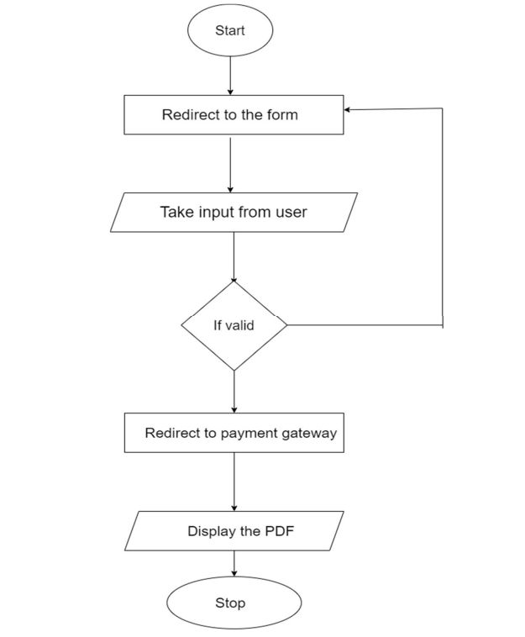

**Fig 1 Flowchart**

**5.3 Use Case Diagram:**

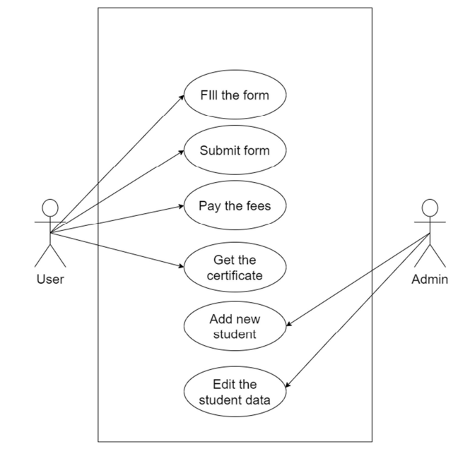

**Fig 2 Use Case Diagram**

**5.3 Component Diagram**

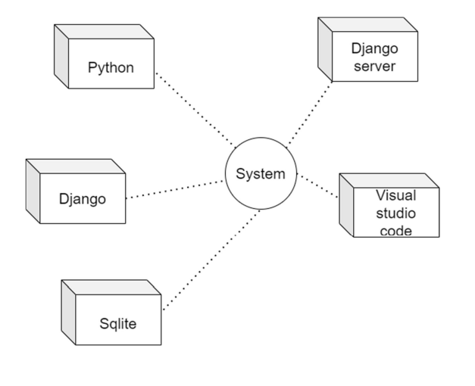

**Fig 3 Component Diagram**

**5.4 ER Diagram**

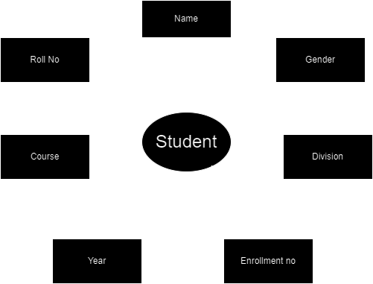

**Fig 4 ER Diagram**

**5.5 Class Diagram**

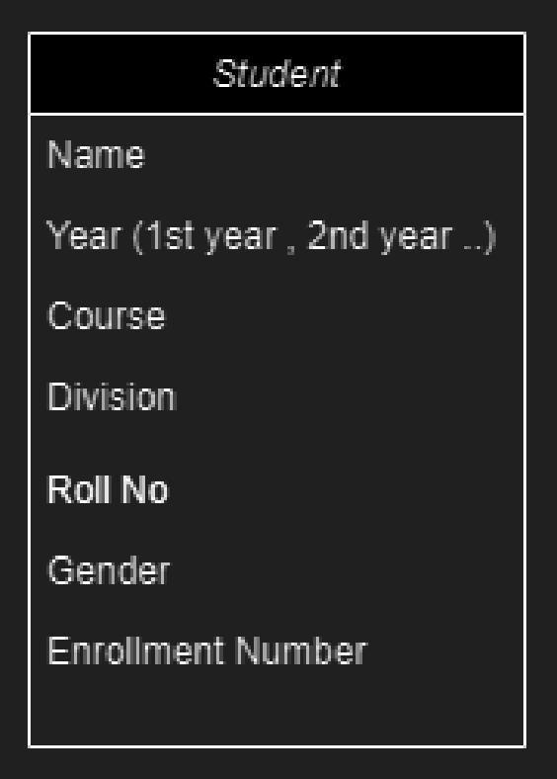

**Fig 5 Class Diagram**

**6.SYSTEM TESTING**

**Introduction**

Testing is one of the most important phases in the software development activity. In software development life cycle (SDLC), the main aim of testing process is quality the developed software is tested against attaining the required functionality and performance. During the testing process software is worked with some particular test case and the outputs of the test case are analyzed whether the software is working according to the expectation or not.

**6.1 Levels of Testing**

Since the errors in the software can be injured at any stage. So, we have to carry out the testing process at different levels during the development. The basic levels of the testing Unit, Integration, System and Acceptance testing. The Unit testing is carried out on coding. Here different modules are tested against the specification produced during design of the modules. In case of integration testing different tested modules are combined into subsystems and tested in case of the system testing the full software is tested and in the next level of testing the system is tested with user requirement document prepared during SRS.

**6.1.1 Functionality Testing**

In functional testing test cases are decided solely on the basis of requirement of program or module and the internals of the program are models are not considered for section of test cases. This is called Black Box testing.

**6.1.2 Structural testing**

In structural testing test cases are generated on actual code of the program or module to be tested. This is called White Box testing.

**6.2 Testing process**

A number of activities must be performed for testing software. Testing starts with test plan. Test plan identifies all testing related activities that need to be performed along with schedule and guidelines for testing. The plan also specifies the levels of testing that need to be done, by identifying the different testing units.

**6.2.1 Test plan**

Test plan is general document for entire project, which defines the scope, approach to be taken and the person responsible for different activities of testing. The inputs for forming test plan are 1. Project plan 2. Requirements document 3. System design

**6.2.2 Test case specification**

Although there is one test plan for entire project test cases have to be specified separately for each test case. Test case specification gives for each item to be tested. All test cases and output expected for those test cases.

**6.2.3 Test case execution and analysis**

The steps to be performed for executive the test case are specified in separate documents called test procedure specification. This document specifies any specific requirement that exists for setting the test environment and describes the methods and formats for reporting the result of testing.

**6.2.4 Unit testing**

Unit testing mainly focus first in the smallest and low level module, proceeding one at a time bottom up testing was performed on each module.

**6.2.5 Integration testing**

Integration testing is a systematic testing for constructing the program structure, while at the same time conducting test to uncover errors associated with interfacing. As the system consists of the number of modules the interfaces to be tested were between the edges of two modules. The software tested under this was incremental bottom-up approach.

**7.Screenshots**

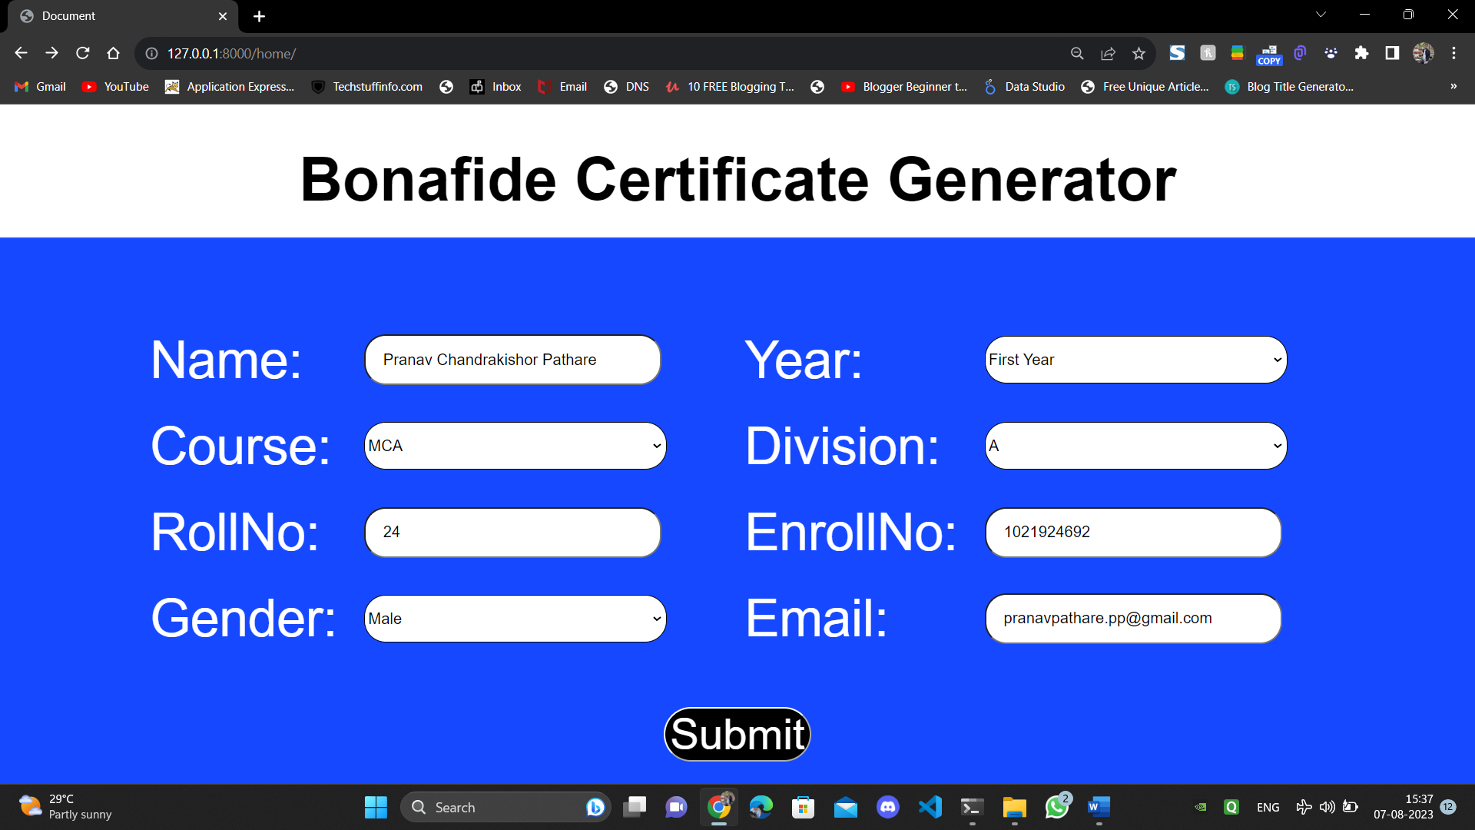

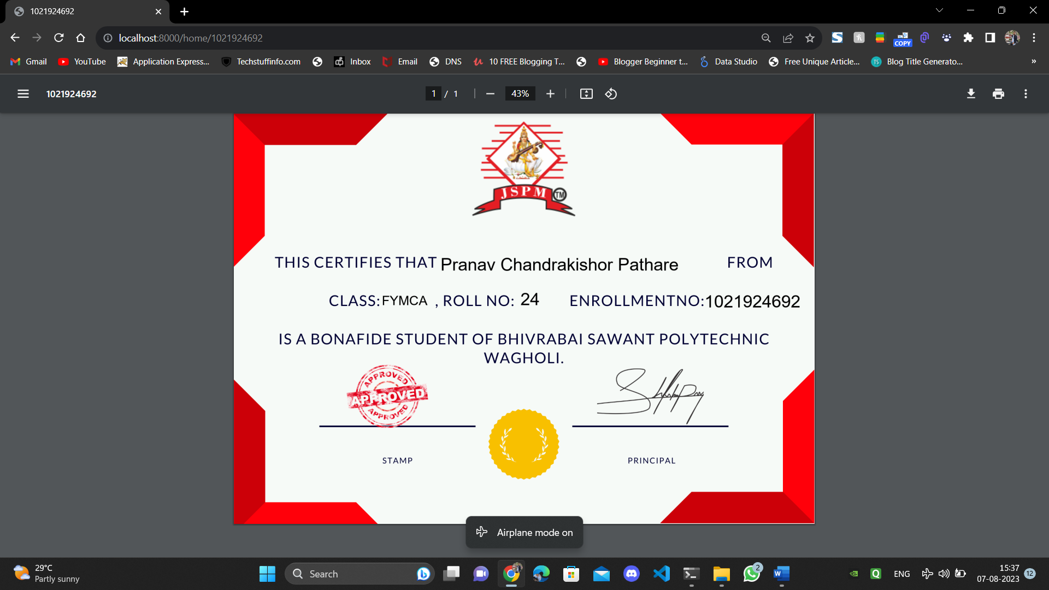

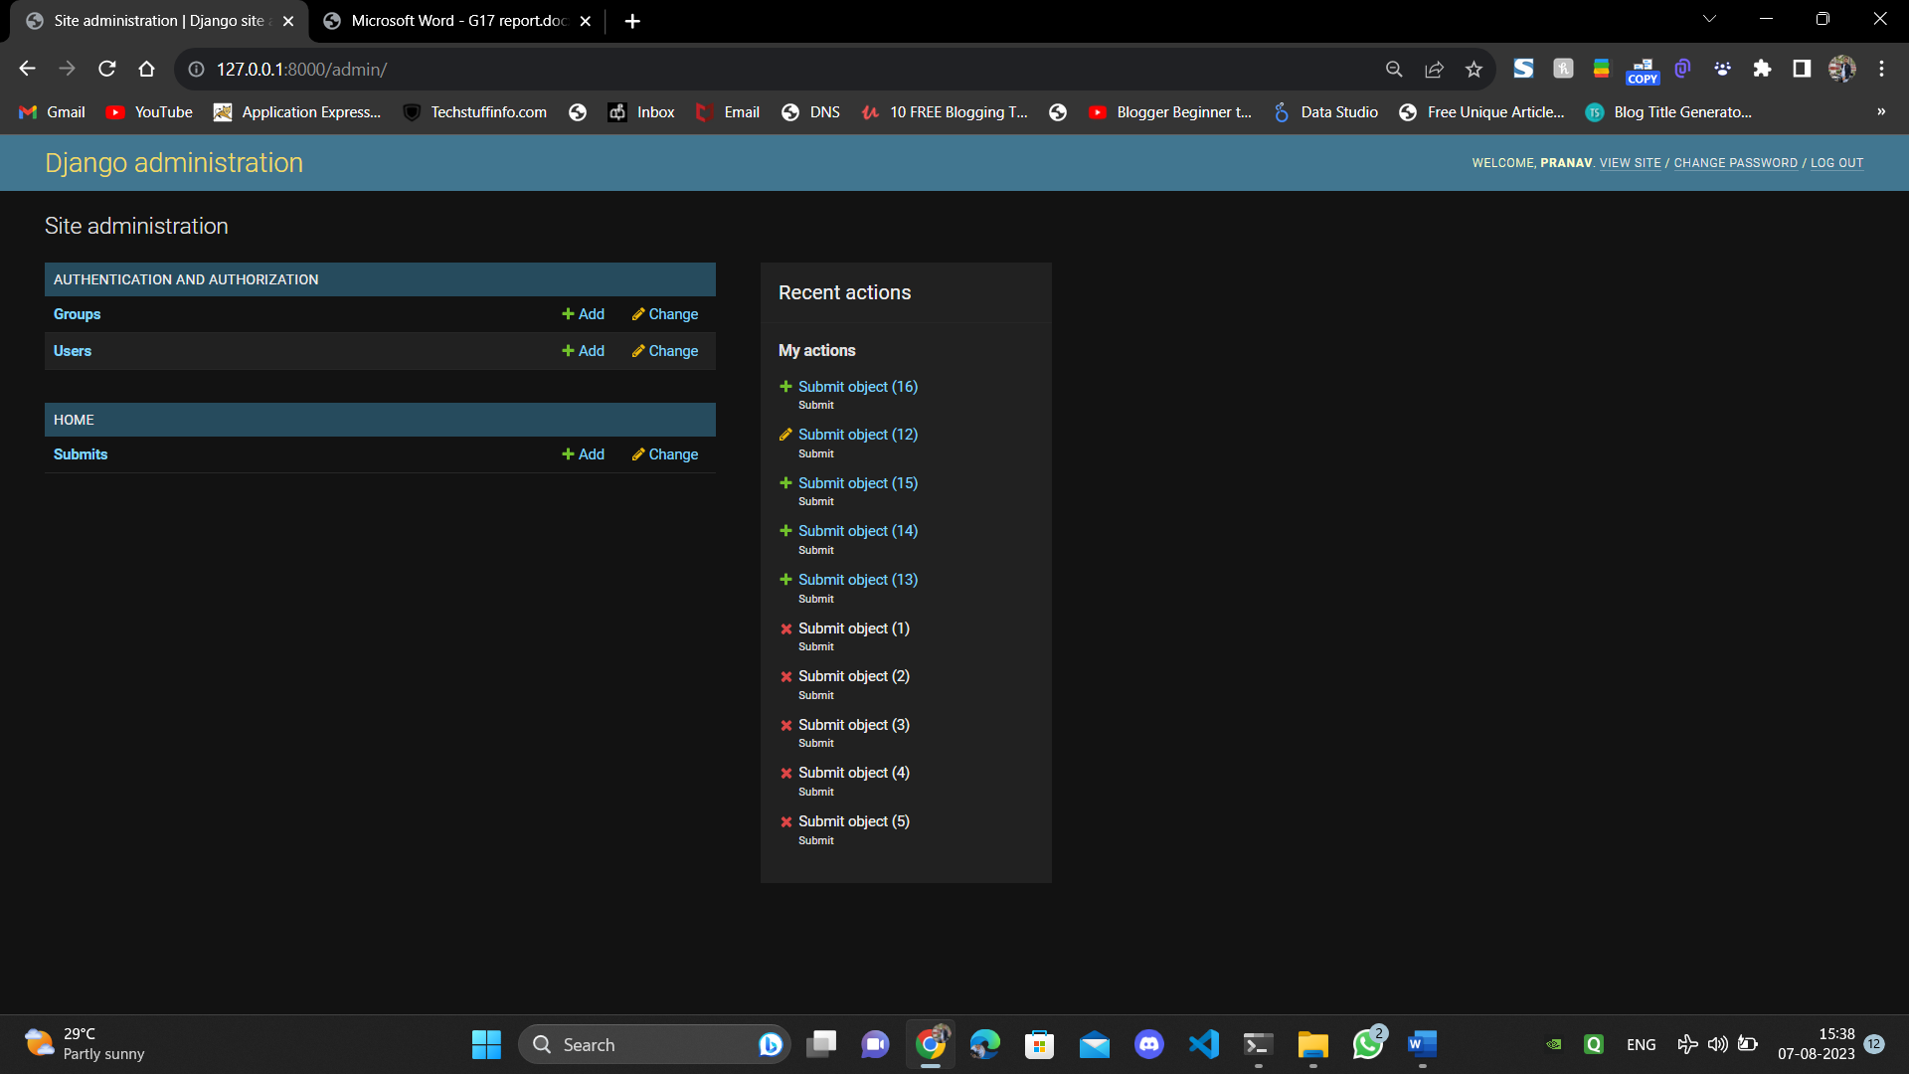

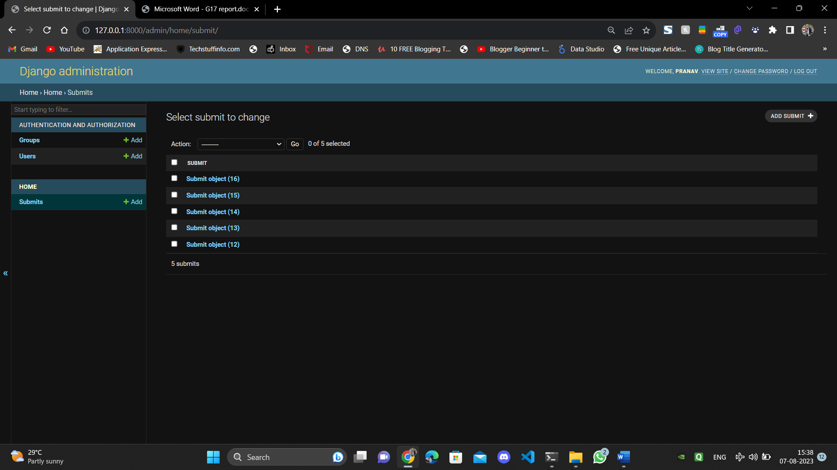

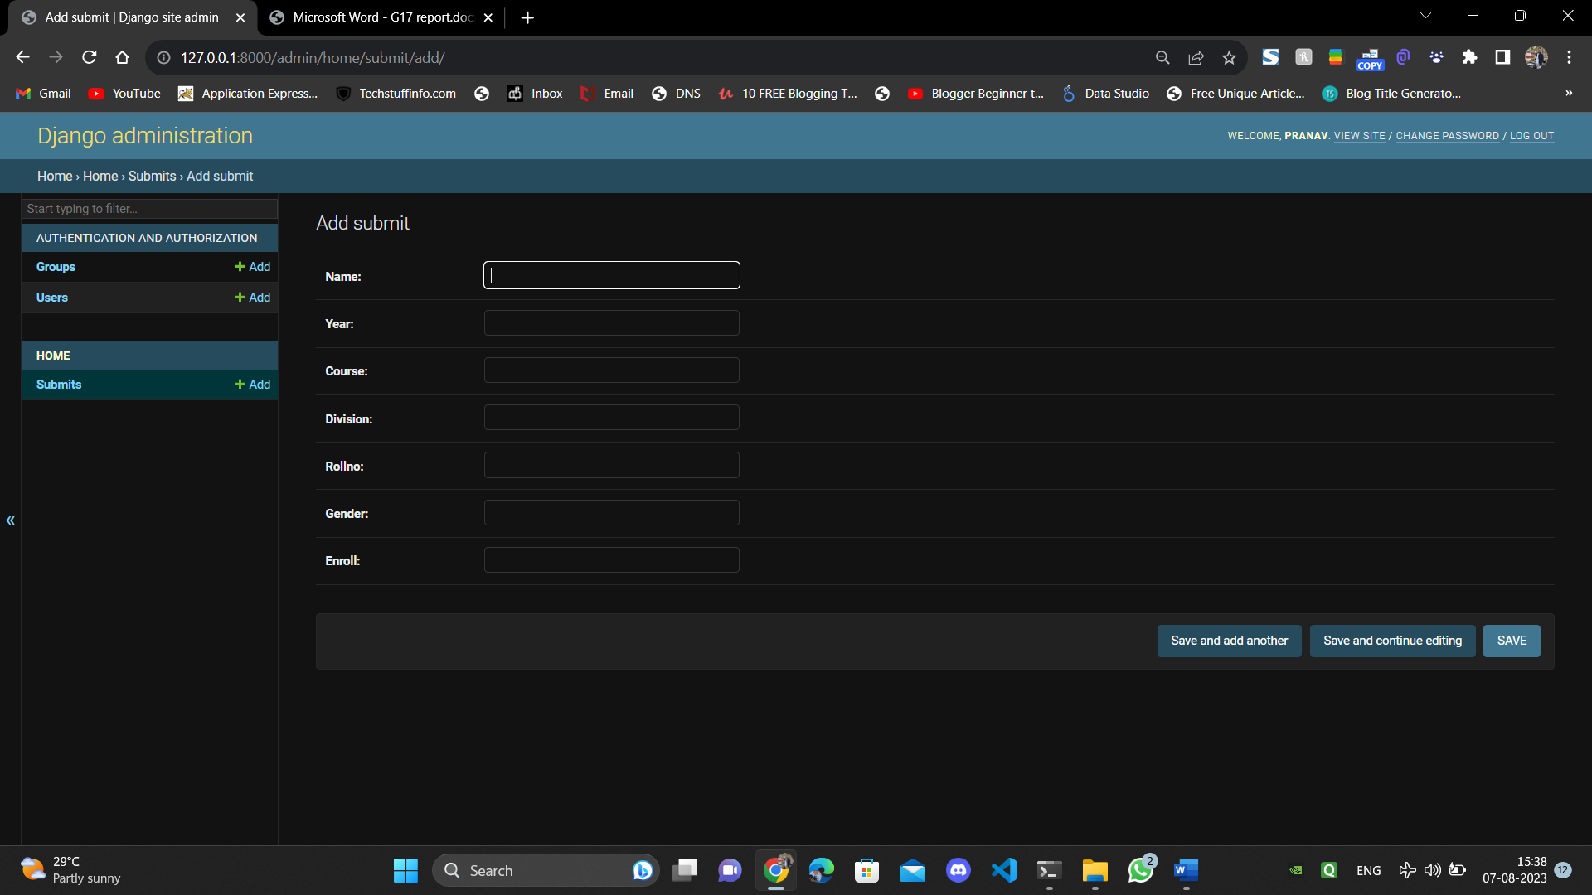

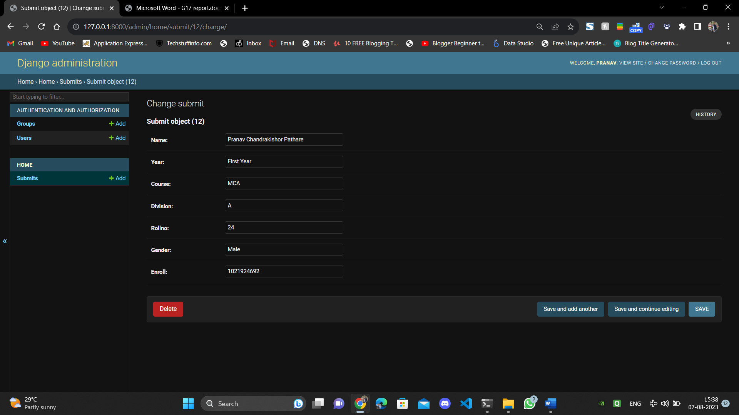

**8.CONCLUSION**

By using this system students will be able to issue bonafide certificate from anywhere from their computers. This will save the precious time of students as well as the staff making the slow process of standing in line and waiting for the signature of principal then going to the bank to pay the fees by creating a platform to both pay and issue a certificate same time with multiple payment options. We have generated this application to create a user-friendly environment for students to get the bonafide certificate online.

**9.BIBLIOGRAPHY**

**HTML -** [**https://www.w3schools.com/html/**](https://www.w3schools.com/html/)

**CSS -** [**https://www.w3schools.com/css/**](https://www.w3schools.com/css/)

**Python -** [**https://www.w3schools.com/python/default.asp**](https://www.w3schools.com/python/default.asp)

**Django -** [**https://docs.djangoproject.com/en/4.2/**](https://docs.djangoproject.com/en/4.2/)